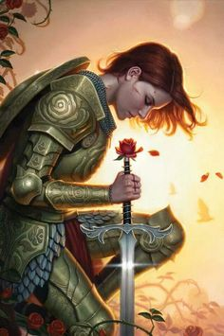
Blue Knights International
Law Enforcement Motorcycle Club, Inc.

Lady Knights of Orange/Alamance (NC) Counties –
Chapter 10
Auxiliary Unit of the Blue Knights of North Carolina -
Chapter 10

Personal Information

Name: ________________________________________ ________________________________________ _____
LAST FIRST MI

Address: ___________________________________________________________________________________________________

_____________________________________________________________________ __________ _______________
City: State: Zip:

Phone: (_______)______________________ (_______)_______________________ (_______)_______________________
HOME CELL WORK

Email: _____________________________________________________________________________________________________

DOB: ______________________________

Sponsor Information

Blue Knight member sponsor: _______________________________________________________________________________

Motorcycle Information
Do you own/ride a motorcycle? YES NO

Acknowledgement

By affixing my signature, I declare that I understand that the Lady Knights of Orange/Alamance (NC) Counties – Chapter 10 is an auxiliary unit of the Blue Knights of North Carolina (Tarheel Regulators) – Chapter 10. Furthermore, I understand that, (1) this auxiliary unit is not, in any way, a part of the Blue Knights International Law Enforcement Motorcycle Club, Inc.; (2) I am not entitled to any of the benefits and/or privileges of the Blue Knights International Law Enforcement Motorcycle Club, Inc. but only to those that have been empowered and approved by the Blue Knights of North Carolina (Tarheel Regulators) – Chapter 10; (3) I am not obligated to the membership dues of the Blue Knights International Law Enforcement Motorcycle Club, Inc., however, in order to maintain membership, I agree to the annual chapter membership dues set forth by the Blue Knights of North Carolina (Tarheel Regulators) – Chapter 10; (4) I have no voting rights in any matters of the Blue Knights of North Carolina (Tarheel Regulators) – Chapter 10; (5) I must abide by any and all rules and regulations set forth by the Blue Knights of North Carolina (Tarheel Regulators) – Chapter 10.

Signature: ________________________________________

Date: ____________________________________________

